NAME | MOAZ tanvir
ROLL NO | 2502036
SECTION | BSAI eve
SUBMITTED TO | Sharif Hussain

Task1:
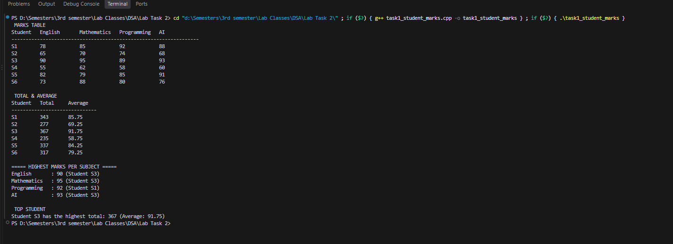
Task2:
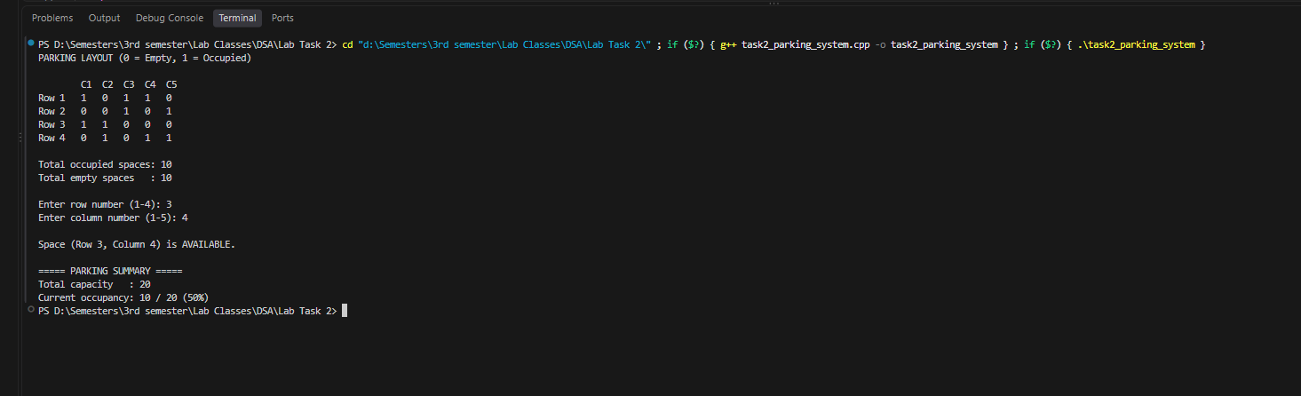

Task3:
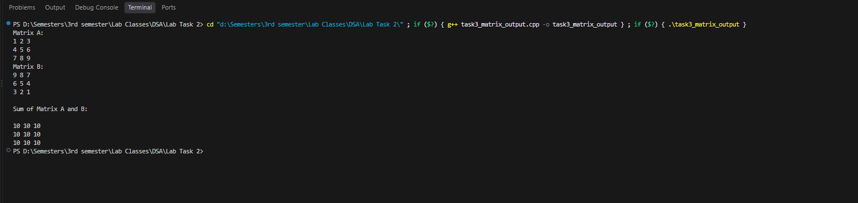

Task4:
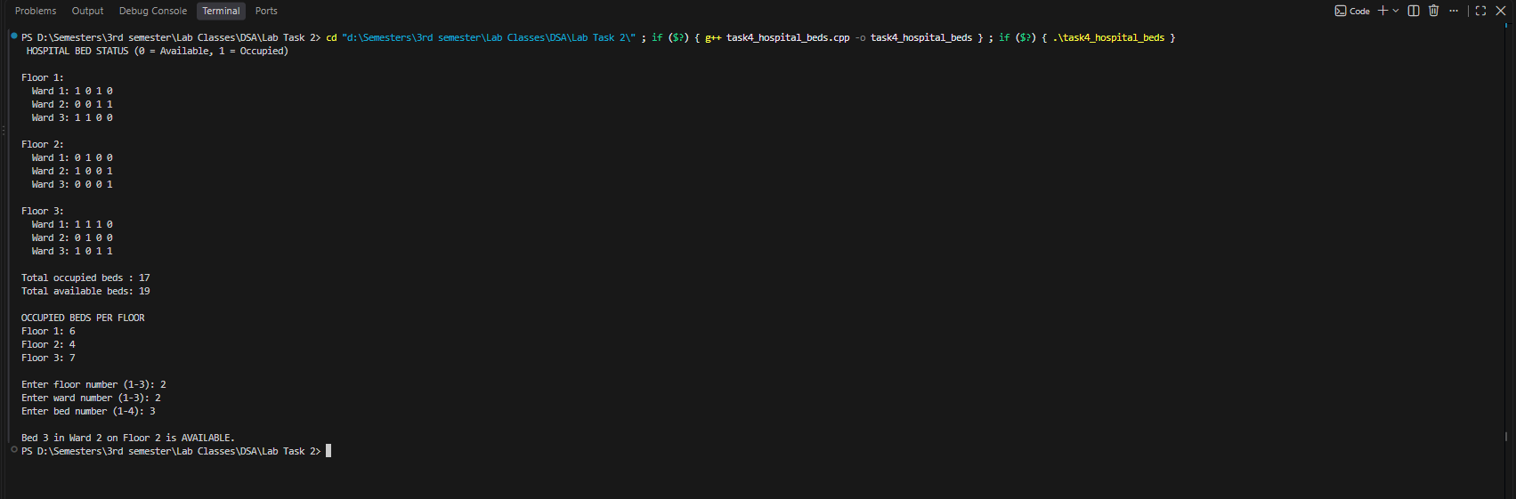
Task5:
